#### UNIVERSITY OF DAR ES SALAAM



#### COLLEGE OF INFORMATION AND COMMUNICATION TECHNOLOGIES (CoICT) DEPARTMENT OF ELECTRONICS AND TELECOMMUNICATION ENGINEERING TE 499 FINAL YEAR PROJECT

#### FINAL REPORT

**PROJECT TITTLE: BILINGUAL ELECTRONIC QUEUING SYSTEM WITH E- TOKEN AND ALERTING MECHANISM.**

**STUDENT’S NAME:** GAMBISHI, WINOCK E

#### REGISTRATION NO: 2021-04-01961

**DEGREE PROGRAM:** BSC IN ELECTRONICS ENGINEERING

**SUPERVISOR:** PROF. BARAKA MAISELI

**………………………… …………………………**

Supervisors signature Students signature

#### DECLARATION

I, Gambishi, Winock E, hereby declare that the progress report titled "Bilingual Electronic Queuing System with E- token and alerting mechanism" submitted for the B.Sc. Electronics Engineering program, Reg. No: 2021-04-01961, represents my own work and efforts. The information, data, and findings presented in this report are genuine, and any external sources utilized are appropriately acknowledged and cited.

All methodologies, analysis, and conclusions drawn in this report are based on ethical research practices and comply with the academic integrity standards set by the University of Dar es salaam. Any contributions or collaborations from external sources are duly credited and referenced in accordance with academic citation guidelines.

Furthermore, no part of this report has been submitted previously for any academic qualification or assessment, at the university of Dar es Salaam or any other institution. This work is entirely my own, and I bear full responsibility for its content and accuracy.

I declare that any material reproduced or adapted from external sources is appropriately referenced, and all citations and references are meticulously included to give credit to the original authors and sources.

I understand the consequences of academic misconduct and affirm that this report has been prepared with honesty, integrity, and a commitment to academic excellence.

Student name: Gambishi, Winock E.

Signature:

Supervisors Name: Prof. Baraka Maiseli.

Signature:

#### ABSTRACT

This report documents the ongoing development of an advanced queue management system aimed at overcoming the challenge lack of notifying alerts for customers when they lose track on the que position or when they are out of the service area premises or outside the parameters and even when customers lose their paper tokens When waiting for specific service. This project, conducted by Gambishi, Winock E, as part of the B.Sc. Electronics Engineering program, addresses deficiencies observed in prior queue management systems, specifically focusing on the provision of an alerting and notification mechanism on the existing model and counteracting the prior models’ limitations on the synchronization of token numbers between counters. Additionally, this report outlines the objectives, methodologies, and progress made thus far, emphasizing the project's goal to create an inclusive system facilitating seamless service provision, optimizing queue management functionalities, and enhancing overall customer satisfaction.

This report provides a comprehensive overview of the project's background, identifying key problems in current queue management systems and elucidating the objectives undertaken to rectify these deficiencies. By analyzing the limitations of the previous system and employing **E-TOKEN Technology and Notification mechanisms**, Additionally, the report indicates the project's timeline, budget, and a detailed methodology while showcasing the significance of the proposed system in improving communication, service distribution, and user experience.

I

**ACKNOWLEDGEMENT**

I would like to express my deepest gratitude to the Almighty God for His grace, guidance, and blessings throughout the course of this project.

I am indebted and extend my deepest gratitude to my supervisor, Prof**. Baraka Maiseli**, whose invaluable guidance, expertise, straightness and constructive feedback significantly contributed to the development and refinement of this project. His mentorship and encouragement were pillars in shaping the progress of this work.

I extend my gratitude to the project coordinator, Dr. **Shamte Kawambwa**, for the support, encouragement, and resources provided throughout the project, which greatly facilitated its successful execution.

I would also like to acknowledge and express appreciation to the previous student, Ng’habi, Samuel Silas, whose initial work on this project laid the foundation for this endeavor. Their efforts and contributions have been instrumental in guiding the direction and scope of this project.

ii

**TABLE OF CONTENTS**

**Contents**

CHAPTER 1. INTRODUCTION 8

1.1 Background of the project 8

1.2 Scope of the project 8

1.3 PROBLEM STATEMENT 9

1.4 Objectives 9

1.4.1 Main objective 9

1.4.2 The Specific objectives 10

CHAPTER 2. LITERATURE REVIEW 11

2.1 Understanding the electronic queue management system. 11

2.2Multilingual queue management systems. 11

2.3 Previous projects and advancements 12

CHAPTER 3. METHODOLOGY 13

3.1 Project Methodology 13

CHAPTER 4. DESIGN OF PROPOSED SYTEM 14

4.1 Design Overview: 14

Block diagram of the proposed system 8

4.2 System Component selection 4.2.1 Microcontroller 8

4.2.2 Wireless Communication 9

4.2.4 Storage Unit 10

4.3 System Architecture 11

4.3.1 Hardware requirements 11

4.3.2 Software requirements 11

CHAPTER 5. SYSTEM IMPLEMENTATION: 12

SYSTEM ENHANCEMENT 13

CHAPTER 6. CONCLUSION AND RECOMMENDATION 15

APPENDIX 16

References 18

##### LIST OF ABBREVIATIONS

|  |  |
| --- | --- |
| CoICT - | College of Information and Communication Technologies. |
| EQMS- | Electronic Queue Management Systems |
| ETE- | Department of Electronics and Telecommunications Engineering. |
| FCFS- | First Come First Served |
| FIFO- | First In First Out |
| LCD- | liquid crystal display |
| LoRa- | Long Range |
| MEQS- | Multilingual Electronic Queuing System |
| QMS- | Queue Management Systems |
| UDSM- | University of Dar es Salaam |
| Wi-Fi - | Wireless Fidelity |

iv

##### TABLE OF FIGURES

figure 1 Block diagram of prior system…………………………………………..……….5

figure 2: Block diagram of prior system ………………………………………………….6

figure 3: Flow chart of the alerting mechanism……………………………………………6

figure 4: Block diagram of the proposed system...………………………………………..7

figure 5: SMS notification on customer’s device…………………………………………12

figure 6: App windows/pages showing navigation through the Proposed application……14

Figure 7: Gantt chart showing project task progres……………………………………….16

v

# **CHAPTER 1. INTRODUCTION**

## 1.1 Background of the project

Today’s world is a world of services, service centers have continuously found ways to manage customers or ques to ensure quality service provision. However, they still face challenges in handling them, arise of the technology of **que management** systems has brought gain to the pain which was earlier felt but leaving behind a very crucial part of notifications and alerting mechanism to customers not only to notify them on their waiting time but also to remind them in cases when they lose their paper tokens or they are out of the premises of the service area.

The proposed system "Bilingual Electronic Queuing System with E-token and Alerting mechanism" tends to serve for those earlier mentioned limitations and provide a seamless service provision and enhance customer satisfaction.

By providing a friendly system which encompasses an electronic non-paper token through their mobile phones for alerting notification on their position on the que by the utilization of the E-token technology**.**

That salient features will bring the gains to the earlier mentioned pains faced in the industry currently, firstly by providing a non-paper e-token that comes through message and on top of that providing alerting notification mechanism through their mobile phones on their estimated waiting time and when their spot to be served is reached.

## 1.2 Scope of the project

The scope of the project encompasses the development of and improved queuing system

addressing the gap or limitation that wasn’t considered in earlier versions, dealing with the challenges of paper token loss and misplacement and lack of reminding and alerting notification providing them with accessibility to electronic token system that provides them with a non-paper token and also offering customers with alerting notifications on their position reach and time to be served when they accidentally misplace or lose their paper tokens or are out of the service provision area and lack a notifying mechanism.

1

# **1.3 PROBLEM STATEMENT**

The absence of reliable alerting notifications support for customers during their time at a service center on their **spot(position) cal**l, the **service waiting time** and scenarios when the paper tokens get accidentally lost or misplaced and cause a lack of seamless service provision in service provision areas like hospitals, government organization. To overcome these limitations, this project aims to build an advanced queuing system that encompasses E-Token with alerting and notification mechanism. The goal is to provide a reliable position assurance(token) that can’t be lost or accidentally misplaced that comes together with a mechanism to remind, alert and notify customers when their que position and when their to-be served time has arrived, improve queue management for fair and swift service distribution, and incorporate better customer satisfaction.

By rectifying these limitations, the proposed solution intends to enhance and optimize the paper token provide a reliable notification and alerting system, optimize queue management. This development aims to significantly enhance overall system efficiency and improve the customer experience.

## 1.4 Objectives

### 1.4.1 Main objective

The main objective is to develop a system which will counteract the gap or add value to the prior model, the improved version will prioritize providing a non-paper E-token together with alerting mechanism if their spot is due and information on estimated service time through customers phones in service centers

2

### 1.4.2 The Specific objectives

|  |  |  |  |
| --- | --- | --- | --- |
| **S/N** | **Specific Objective** | **Methods** | **Output** |
| 1 | Design a digital token system | System architecture designing, database integration and UI/UX development | Afunctional E-token system replacing paper-based tokens |
| 2 | Develop an SMS integration and potential App for management and alerting notification | Integrate API (Briq.tz), SMS gateway set up | A real-time alerting mechanism for customers via SMS/App |
| 3 | Analysis and evaluation of the system | Usability testing, performance testing, user feedback collection | Insights on system efficiency, reliability and user satisfaction. |
| 4 | Implementation of the system | Deployment, real-world testing. | A fully operational queuing system in a service center |

Table 1-1 Specific objective mapping

3

# **CHAPTER 2. LITERATURE REVIEW**

The literature review conducted herein encapsulates a comprehensive analysis of scholarly works, encompassing research findings, scholarly opinions, and insights from various researchers, scholars, authors, and students within the previous decade. Focusing on the specific timeframe of the last 10 years, this review aims to accumulate a wealth of knowledge and comprehension concerning the realm of electronic and digital documents. Rigorous exploration of published writings and diverse viewpoints was undertaken to understanding, a diverse array of sources from reputable databases such as Google Scholar, ResearchGate and Academia were meticulously surveyed. These databases were carefully selected due to their relevance and alignment with the overarching purpose and objectives of this study, allowing for a broad spectrum of literature that elucidates the evolving landscape of electronic and digital document management within the designated timeframe.

## 2.1 Understanding the electronic queue management system.

Based on the 2014 WaveTech report, EQMS is defined as a system that optimizes queues for better user experiences. It utilizes first Come first served (FCFS) or first in first out (FIFO) situations. It consists of hardware like token generators, digital displays, and audio announcements, along with software for data management. Benefits include shorter wait times, improved customer experience, efficient operations, data-driven decision-making, and a positive brand image. EQMS finds applications in various sectors like banking, healthcare, retail, government services, and event management. Despite the report's age, its insights remain relevant, although it lacks a detailed analysis of human aspects and customer satisfaction. Future research could explore these areas and delve deeper into EQMS technology and its evolving applications.

## 2.2Multilingual queue management systems.

The research paper "Challenges and Opportunities of Multilingual Queue ManagementSystems" by A. Kumar et al. (2023) discusses technical challenges and potential solutions for multilingual support in queue management systems. It identifies

4

Significant hurdles in content translation, language detection, voice and text support, cultural sensitivity, and technical limitations when implementing Multilingual Queue Management Systems (MQMS). The paper emphasizes the importance of overcoming these challenges to achieve improved accessibility, enhanced user experience, increased customer satisfaction, reduced wait times, and global business expansion. However, gaps exist in addressing these challenges effectively, calling for further exploration and technological advancements to bridge these barriers for successful MQMS implementation.

## 2.3 Previous projects and advancements

In 2023/2024, Ng’habi, Samuel Silas, a student at the University of Dar es Salaam, devised a prototype “Bilingual Electronics Queuing System” which specifically aimed at addressing the people who didn’t understand just one language or special for native speakers also encompassing visible and friendly display for the tokens being served and advertisement for improving user’s experience, Nonetheless, this prototype still provides paper tokens which can be **misplaced** or **lost** and also in a small amount contribute to litters in service areas and also lacked **customers notifications** and **alerting mechanism** when their position is due and also faced a challenge in the synchronization of tokens between counters. This project's objective is to extend and refine Ng’habi, Samuel Silas’s prior work by addressing these identified shortcomings. The aim is to expand upon the initial prototype and develop an advanced queuing system that rectifies observed deficiencies, thereby improving overall system efficiency.

5

# **CHAPTER 3. METHODOLOGY**

## 3.1 Project Methodology

The project methodology is Prototyping which includes the following steps;

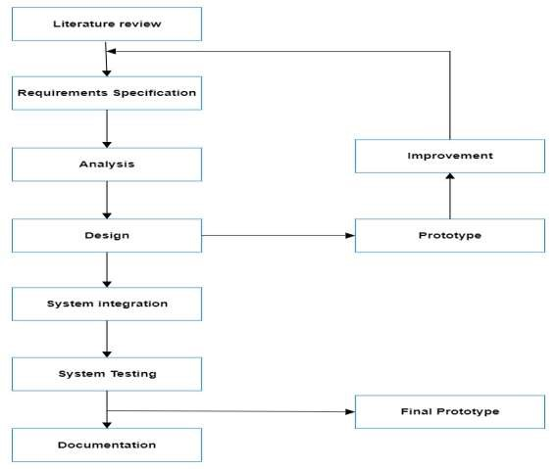

figure 1 Block diagram of prior system

6

# **CHAPTER 4. DESIGN OF PROPOSED SYTEM**

## 4.1 Design Overview:

The project aims to extend a scope from the previous project whose block diagram was as observed below;

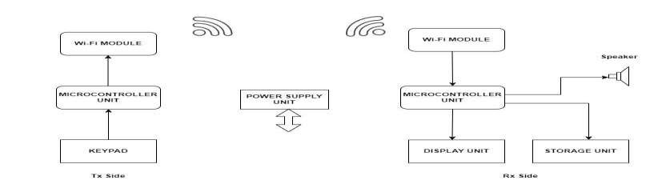

figure 2: Block diagram of prior system

And adding the functionality of e-token generator and SMS/app notifications, below is the flow chart of the proposed scheme.

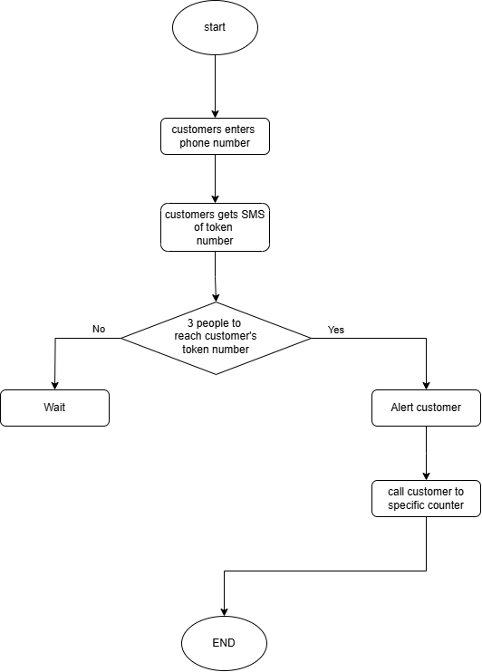

7

figure 2: flow chart of customer alerting mechanism

## Block diagram of the proposed system

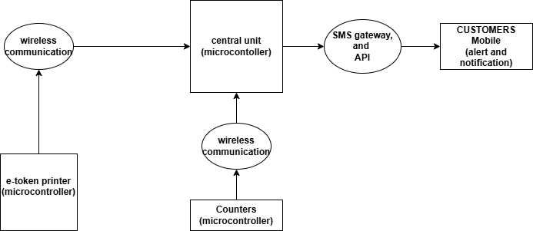

figure 3: Block diagram of proposed system

## 4.2 System Component selection 4.2.1 Microcontroller

|  |  |  |  |  |
| --- | --- | --- | --- | --- |
| **Criteria** | **ESP32** | **Raspberry Pi** | **ATmega328P** | **Choice** |
| Processing Power | High | High | Low | **ESP32** |
| Wireless Capability | Built-in Wi-Fi | Requires dongle | None |
| Ease of Use | Moderate | Moderate | High |
| Power Consumption | Low | High | Low |
| Multimedia  Capability | High | High | Moderate |
| **Justification** | Chosen for its high processing power, built-in Wi-Fi capability, moderate ease of use, and moderate power consumption. This makes it suitable for handling the keypad input and transmitting signals via Wi-Fi efficiently. | | | |

Table 4-2 Decision Matrix for Microcontroller

## 4.2.2 Wireless Communication

|  |  |  |  |  |
| --- | --- | --- | --- | --- |
| **Criteria** | **Wi-Fi** | **LoRa** | **Bluetooth** | **Choice** |
| Range | Short to Medium | Long | Short | **Wi-Fi** |
| Data Rate | High | Low | Moderate |
| Power Consumption | Moderate to High | Low | Low |
| Interference | Moderate | Very High | Moderate |
| **Justification** | Selected for fast data transmission and moderate range, ensuring reliable communication between the transmitter and receiver in the queue management system. Despite moderate power consumption and complexity, Wi-Fi's efficiency and widespread availability make it a practical choice for real-time signal transmission in indoor environments. | | | |

Table 4-3 Decision matrix for wireless communication

**4.2.3 Commanding Unit**

|  |  |  |  |  |
| --- | --- | --- | --- | --- |
| **Criteria** | **4x4 Keypad** | **Push Buttons** | **Touch Screen** | **Choice** |
| Input Method | Physical buttons | Physical buttons | Touch screen | **4x4**  **Keypad** |
| Ease of Use | Moderate | Easy | Easy |
| Durability | High | High | Moderate |
| Cost | Moderate | Low | High |
| Space Requirement | Moderate | Low | High |
| **Justification** | Selected due to its moderate ease of use, high durability, moderate cost, and moderate space requirement. Although push buttons or touch screens could be alternatives, the keypad offers physical buttons that are straightforward for tellers to input customer token numbers quickly and reliably | | | |

Table 4-4 Decision matrix for Commanding unit

## 4.2.4 Storage Unit

|  |  |  |  |  |
| --- | --- | --- | --- | --- |
| **Criteria** | **DF Player** | **SD Card**  **Reader** | **BT Speaker** | **Choice** |
| Audio Storage | Onboard memory  card | SD card | Bluetooth device | **DF** |
| Sound Quality | Good | Good | Good | **Player** |
| Portability | Limited | Portable | Portable |
| Connectivity | N/A | SD card slot | Bluetooth |
| **Justification** | Selected for its onboard memory card storage, good sound quality, and ease of use. This device efficiently plays audio files, including the various announcements required in the queue management system. | | | |

Table 4-5 Decision matrix for user input

## 4.3 System Architecture

### 4.3.1 Hardware requirements

|  |  |
| --- | --- |
| **Requirement** | **Component** |
| Microcontroller | ESP32 |
| Keypad/Input Device | 4x4 keypad |
| DF Player | DF Player module with audio storage capabilities |
| Display Device | TV |
| Speaker | External speaker for audio output |
| Power Supply | Stable power source (e.g., 5V, 2A) for all components |
| Connectivity | Wi-Fi module for wireless communication |
| Environmental Housing | Enclosure to protect components from dust and damage |
| Wiring | Cables and Connectors |

Table 4-6 Hardware requirements

### 4.3.2 Software requirements

|  |  |
| --- | --- |
| **Requirement** | **Software** |
| Operating System | Compatible with Windows 10, macOS, Linux |
| Development  Environment | Python friendly firmware, and arduino IDE |
| Communication  Protocol | Wi-Fi (TCP/IP), Serial Communication (UART) |
| Firmware | Wokwi |

Table 4-7 Software requirements

# **CHAPTER 5. SYSTEM IMPLEMENTATION:**

* Successfully integrated SMS notification through mobile phones, these ,made possible be integrating with SMS Gateway, Briq.tz for bulk SMS that would be utilized in notifications

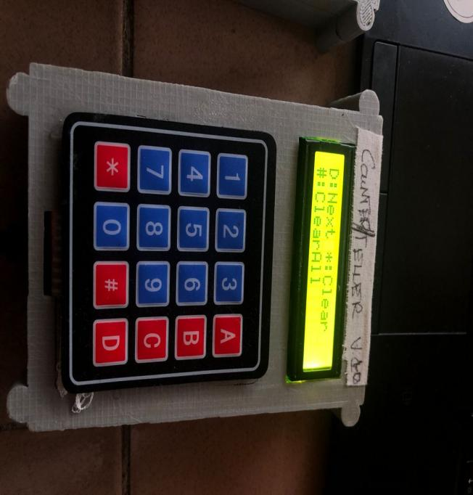

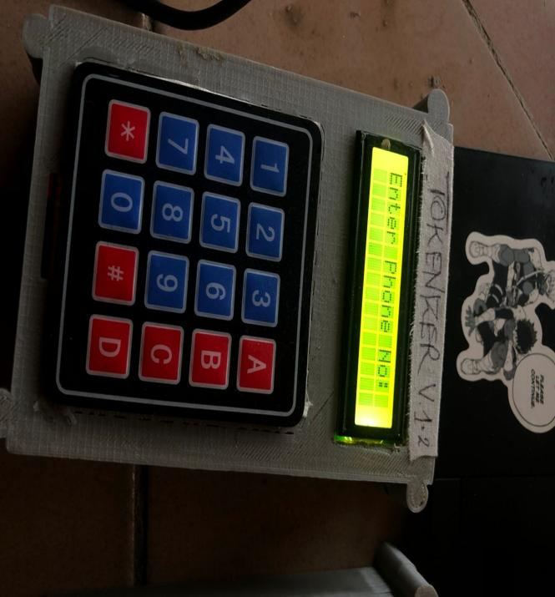

figure 4: image of Tokenizer that takes in phone number and the teller’s counter

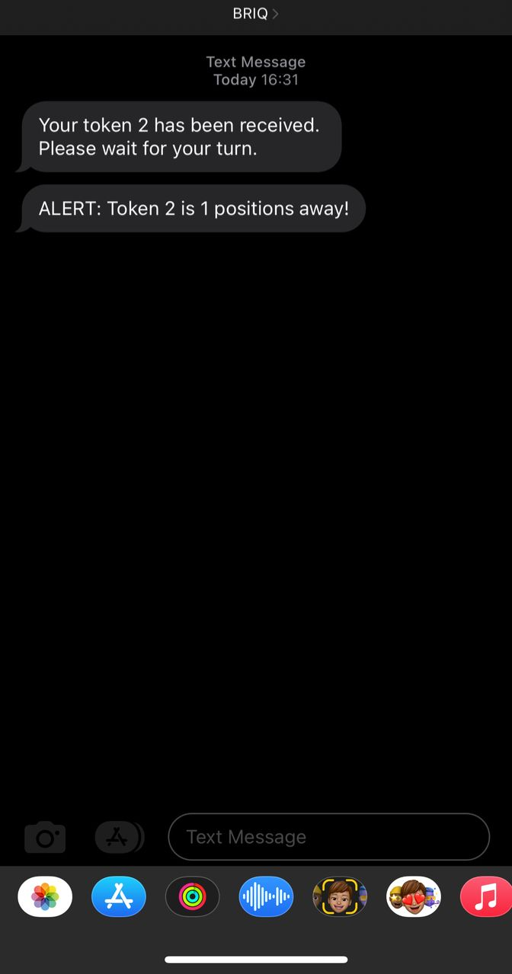

figure 5: SMS notification on customer’s device

## SYSTEM ENHANCEMENT

App integration for alerting notifications, together with the SMS mechanism also mushed up with application labeling it the “QUEUING SYSTEM” app or “MFUMO WA FOLENI”, in which it involved additional features like:

* Choosing a specific service center to be served( either bank hospital or government organization) and their respective branches
* status of the que at the center(how many customers being served at the moment)
* Estimated waiting time
* Option to cancel the token order
* Easy navigation through the application

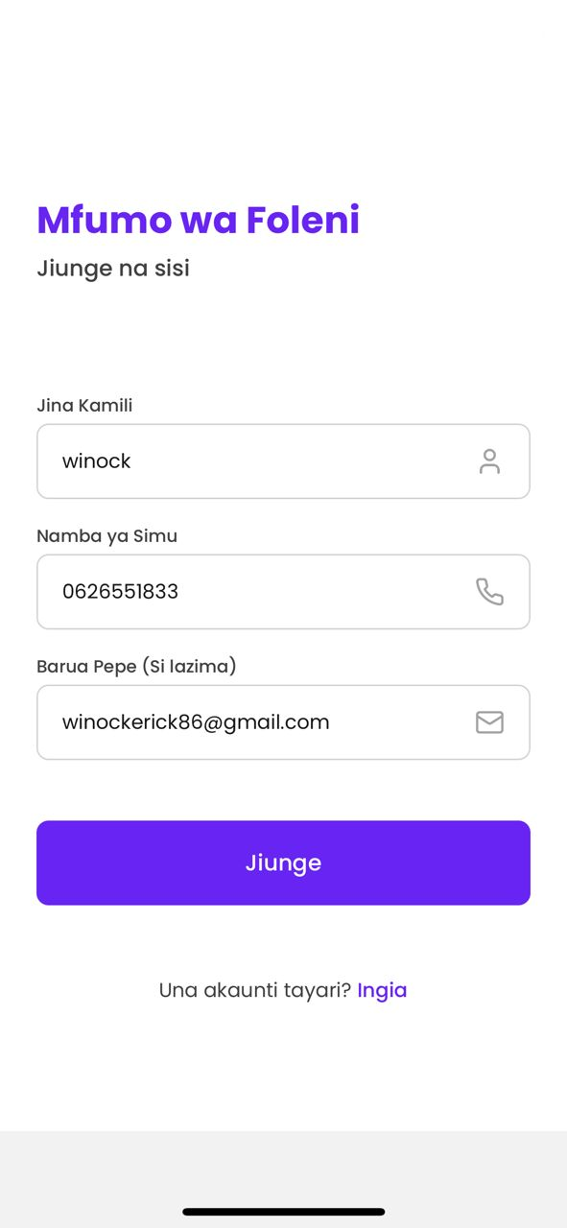

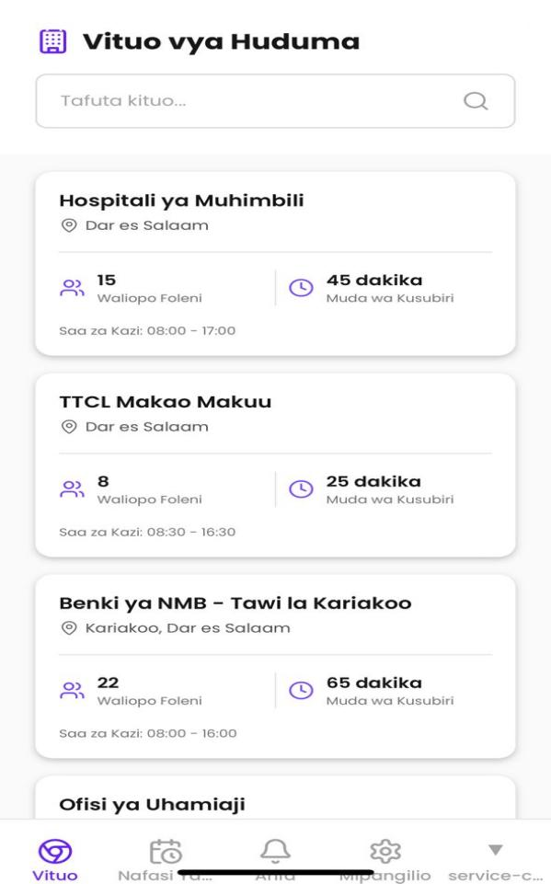

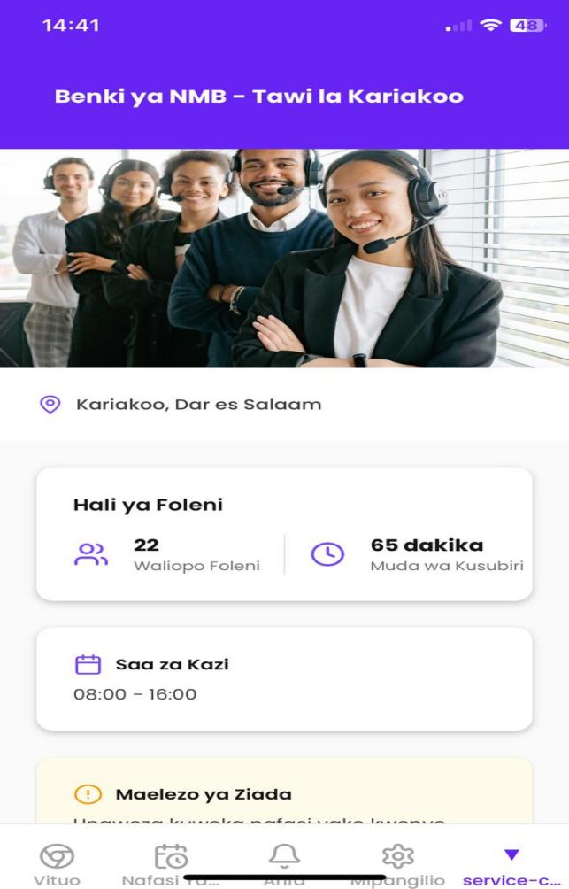

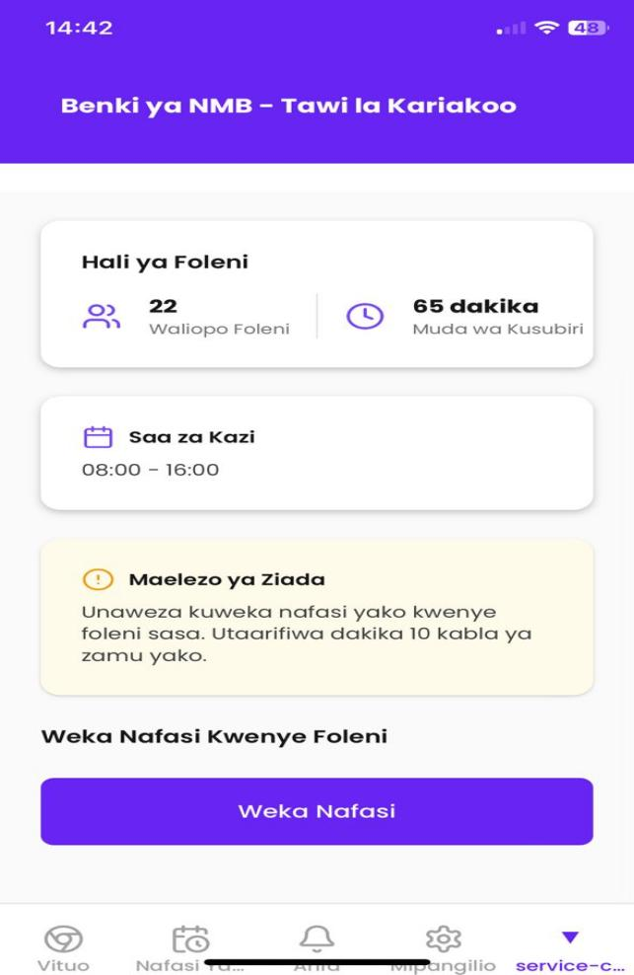

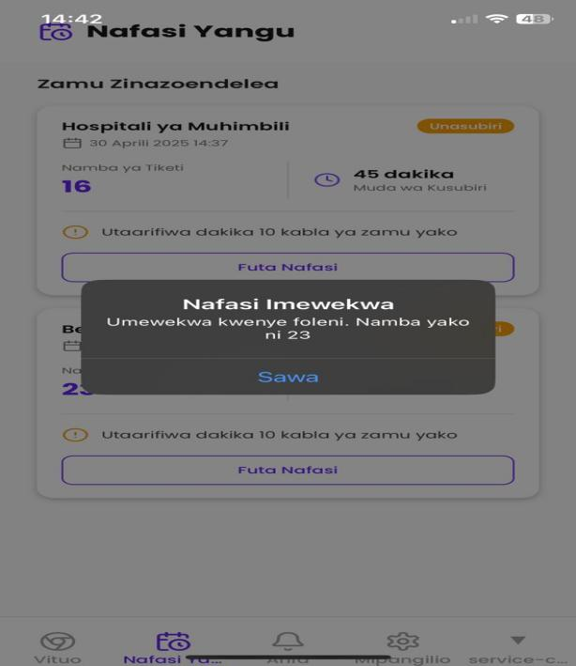

figure 6: App windows/pages showing navigation through the Proposed application

# **CHAPTER 6. CONCLUSION AND RECOMMENDATION**

The essence of the availability of **alerting and notifying mechanism** is of more gain rather than pain-oriented, and the gap that existed in the previous models is well addressed, users can now receive om time notification concerning their token number and also their time to be served on spot reach in service centers through their **mobile phones,** in varying scenarios, when the user is far away from the service centre’s perimeter, this model is indeed of helpfulness it digitalises the token part user relationship and interaction

Future work will/should focus on enhancing system **scalability** for larger queues and larger service centers proper enhancement of the **application notification** mechanism securing it with a **firm** back-end that communicates well with the prior model, and also Exploring AI techniques that will optimize queue management experience including **estimated waiting time** and also preferred **customer service**

# **APPENDIX**

**Gant t chart and project budget**

|  |  |  |
| --- | --- | --- |
| **S/N** | **TASK** | **STATUS** |
| 1 | Literature review | Done |
| 2 | Block Diagram of proposed system | Done |
| 3 | System requirement establishment for proposed system | Done |
| 4 | System component selection | Done |
| 5 | Design a digital token system (Tokenizer block) | Done |
| 6 | SMS integration for alerting mechanism (alerting block) | Done |
| 7 | Implementation of the proposed system | Done |
| 8 | System Enhancement | Done |
| 9 | Testing | Done |
| 10 | Documentation | Done |

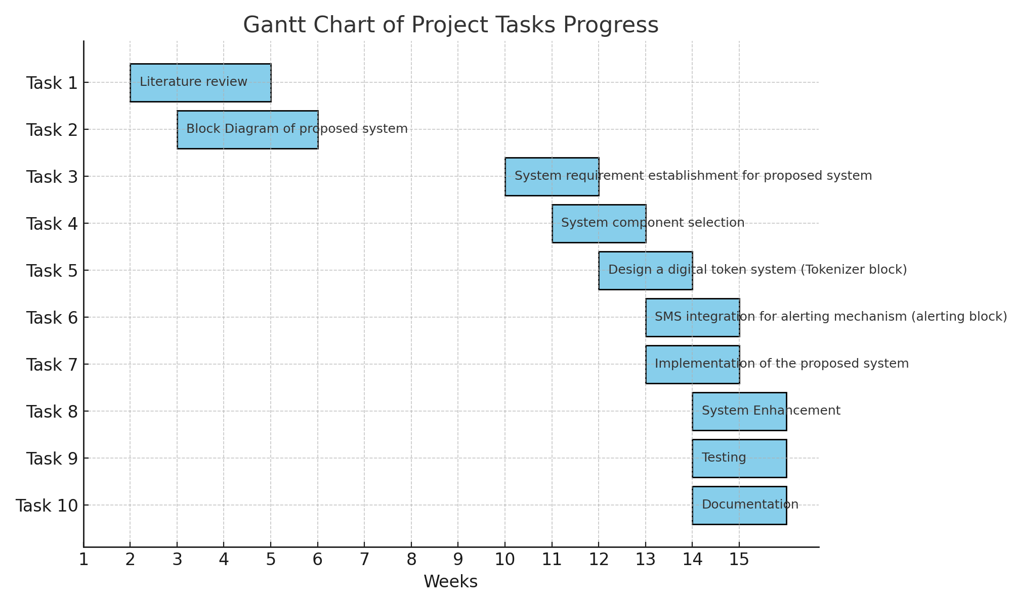

Figure 7: Gantt chart showing project task progress

**Project budget**

|  |  |  |  |
| --- | --- | --- | --- |
| **Item** | **Quantity** | **Unit price(TZS)** | **Total price(TZS)** |
| **4x4 keypad** | **2** | **20,000** | **40,000** |
| **ESP 32** | **2** | **50,000** | **100,000** |
| **Raspberry pi 4** | **1** | **300,000** | **300,000** |
| **souldering** | **1** | **10,000** | **10,000** |
| **housing** |  | **25,000** | **25,000** |
| **Cable and connectors** | **1** | **15,000** | **15,000** |
| **internet** |  | **50,000** | **50,000** |
| **TOTAL** |  |  | **535,000** |

# References

1. Designing Queuing Systems: [https://www.amazon.com/Introduction-QueueingTheory-Applications-Statistics/dp/0817684204](https://www.amazon.com/Introduction-Queueing-Theory-Applications-Statistics/dp/0817684204)
2. Electronics for Beginners:<https://www.allaboutcircuits.com/>
3. Arduino Programming Tutorial:<https://create.arduino.cc/editor>
4. Rao, G. S., & Mnyanga, E. A. (2022). Queuing systems in the cafeterias at the University of Dodoma, Tanzania. *International Journal of Mathematics in Operational Research*, *22*(1), 127-141.
5. Bose S.J., AN INTRODUCTION TO QUEUING SYSTEMS, Kluwer/Plenum

Publishers, 2002.

1. Rose, C., & Nkirina, S. P. (2017). The Relationship Between Perceived Waiting Time

Management And Customer Satisfaction Levels Of Commercial Banks In

Kenya. *International Journal of Innovative Research and Advanced Studies*

*(IJIRAS), 4(9).*

7. Mohamud, A. A. (2016). *Automated Queuing And The Experience Of Kenya*

*Commercial Bank Retail Customers In Nairobi Kenya* (Doctoral dissertation,

University of Nairobi).

8. Ochieng, J., & Kegoro, H. (2021). AUTOMATED QUEUING SYSTEM ON

PERFORMANCE OF SELECTED STATE-OWNED COMMERCIAL ENTITIES IN

KENYA: A CONCEPTUAL PAPER.

9. Rao, G. S., & Mnyanga, E. A. (2022). Queuing systems in the cafeterias at the

University of Dodoma, Tanzania. *International Journal of Mathematics in Operational*

*Research*, *22*(1), 127-141.

10. Bose S.J., AN INTRODUCTION TO QUEUING SYSTEMS, Kluwer/Plenum

Publishers, 2002.